**ACKNOWLEDGEMENTS**

We would like to express our heartfelt appreciation to Ms. Swati Sheoran, our Project Supervisor at SRM Institute of Science and Technology, Delhi-NCR Campus, Modinagar, for her invaluable insights and expertise in the subject matter, which motivated us to work diligently.

We would like to extend our sincere thanks to Dr. S. Vishwanathan, Director of SRM Institute of Science and Technology, Delhi-NCR Campus, Modinagar, for his unwavering support that enabled us to undertake and complete our project work. Our special thanks go to Dr. R. P. Mahapatra, Dean Computer Science and Engineering at SRM Institute of Science and Technology, Delhi-NCR Campus, Modinagar, for his valuable guidance and unconditional support.

We would like to express our gratitude to **Avneesh Vashisht**, HOD CSE 2nd year at SRM Institute of Science and Technology, Delhi-NCR Campus, Modinagar, for his suggestions and encouragement in completing this project.

Finally, we would like to express our sincere appreciation to our parents, family members, and friends for their unwavering support and encouragement, and to all our well-wishers.

Lakshya Chaudhary ---> RA2311026030064

Vidhan Veerbhan --> RA2311026030066

Sarthak Aggarwal --> RA2311026030118

Nirupam Saini --> RA2311026030119

**DECLARATION**

We,

Lakshya Chaudhary [Reg.No.:RA2311026030064]

Vidhan Veerbhan[Reg.No.:RA2311026030066]

Sarthak Aggarwal [Reg.No.:RA2311026030118]

Nirupam Saini [Reg.No.:RA2311026030119]

hereby declare that the work which is being presented in the project report” Currency Convertor” is the record of authentic work carried out by us during the period in October’23 and submitted by us in partial fulfilment for the award of the degree “Bachelor of Technology in Computer Science and Engineering” to SRM IST, NCR Campus, Ghaziabad (U.P.). This work has not been submitted to another University or Institute for the award of any Degree/Diploma.

**INTRODUCTION**

Python is an interpreted, object-oriented, high-level programming language with dynamic semantics. Its high-level built in data structures, combined with dynamic typing and dynamic binding, make it very attractive for Rapid Application Development, as well as for use as a scripting or glue language to connect existing components together.

This project delves into the development of a Currency Convertor using Python. The primary focus of this project is to explore the capabilities of web development with Python and also harnessing external libraries to parse and manage currency information. The project involves building a application that allows users to know information regarding different currencies for example

1 dollar = 84.07 rupees.

Dealing with foreign exchange and currency conversion has become part of the routine for many developers working in the fintech space, and analysers help others make informed decisions. However, getting the currency conversion right is crucial, as currency exchange rates fluctuate.

What is a currency converter app?

The currency converter application is a tool that helps users precisely convert one currency's price to another's. The best part is that conversions happen real quick, within milliseconds. Users can keep track of continuously fluctuating rates with little effort.

A universal currency converter is an online program where currency values can be easily converted based on current exchange rates. These currency converters can be readily found online and can quickly convert the value of one currency to another, such as euros to pounds or dollars to euros.

**HARDWARE REQUIREMENTS**

• Processor: Any modern processor with at least 1 GHz speed.

• RAM: 512 MB RAM or higher

• Graphics: Integrated graphics card or dedicated graphics card with basic capabilities.

• Storage: A few megabytes of available storage space for the game installation.

• Operating System: Compatible with Windows

• Display: Any monitor or screen with a resolution of 800x600 pixels or higher.

• Sound: Basic sound card for in-game sounds and effects (optional).

• Input Devices: Keyboard for user input during gameplay and development.

**SOFTWARE REQUIREMENTS**

* Python Programming Language
* External Python Libraries: Install the following libraries using Python package managers like pip
* Database Management System
* Web Browser.

**ADVANTAGES**

1. Convenient to use

Online currency convertors are matchless compared to traditional currency conversion methods.

2. Time-saving

As stated in the section above, you don’t have to visit world banks or currency exchange centers to convert a currency value to the desired currency value.

3. Budget planning

As a student [studying abroad](https://www.msmunify.com/study-abroad/), a professional on an international business trip, or a tourist traveling overseas, you need to manage a budget and plan your expenses.

4. Cost-effective

This is one of the stellar features of online currency convertors, as they can be leveraged when you need them without having to spend money for currency conversions.

**Flowchart**

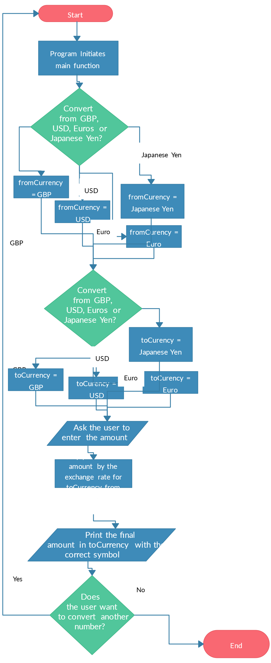

**DICTIONARY USED IN**

**CURRENCY CONVERTOR**

This is a dictionary used in code of python used in CURRENCY CONVERTOR which basically show or provides the information regarding the currency of different countries.

For e.g.:-

Argentine Peso 11.666958 0.085712  
Australian Dollar 0.017785 56.226206  
Bahraini Dinar 0.004473 223.564129  
Botswana Pula 0.159195 6.281606  
Brazilian Real 0.067480 14.819249  
British Pound 0.009151 109.275370  
Bruneian Dollar 0.015640 63.937542  
Bulgarian Lev 0.021499 46.514767  
Canadian Dollar 0.016391 61.007247  
Chilean Peso 11.252895 0.088866  
Chinese Yuan Renminbi 0.084719 11.803712  
Colombian Peso 50.738996 0.019709  
Czech Koruna 0.277430 3.604512  
Danish Krone 0.081984 12.197576  
Emirati Dirham 0.043689 22.889071  
Euro 0.010992 90.974976  
Hong Kong Dollar 0.092480 10.813121  
Hungarian Forint 4.398784 0.227336  
Icelandic Krona 1.636779 0.610956  
Indonesian Rupiah 184.833077 0.005410  
Iranian Rial 500.166756 0.001999  
Israeli Shekel 0.044401 22.521916  
Japanese Yen 1.784162 0.560487  
Kazakhstani Tenge 5.798624 0.172455  
Kuwaiti Dinar 0.003648 274.135430  
Libyan Dinar 0.057209 17.479850  
Malaysian Ringgit 0.051291 19.496661  
Mauritian Rupee 0.552022 1.811522  
Mexican Peso 0.237020 4.219059  
Nepalese Rupee 1.600750 0.624707  
New Zealand Dollar 0.019636 50.925912  
Norwegian Krone 0.129986 7.693137  
Omani Rial 0.004580 218.348093  
Pakistani Rupee 3.306649 0.302421  
Philippine Peso 0.688417 1.452607  
Polish Zloty 0.047451 21.074508  
Qatari Riyal 0.043302 23.093438  
Romanian New Leu 0.054676 18.289577  
Russian Ruble 1.159164 0.862691  
Saudi Arabian Riyal 0.044611 22.416030  
Singapore Dollar 0.015640 63.937542  
South African Rand 0.211091 4.737298  
South Korean Won 16.308328 0.061318  
Sri Lankan Rupee 3.484595 0.286977  
Swedish Krona 0.125128 7.991819  
Swiss Franc 0.010287 97.207681  
Taiwan New Dollar 0.382346 2.615430  
Thai Baht 0.394791 2.532986  
Trinidadian Dollar 0.080759 12.382449  
Turkish Lira 0.405904 2.463638  
US Dollar 0.011896 84.060113  
Venezuelan Bolivar 46352.247093 0.000022

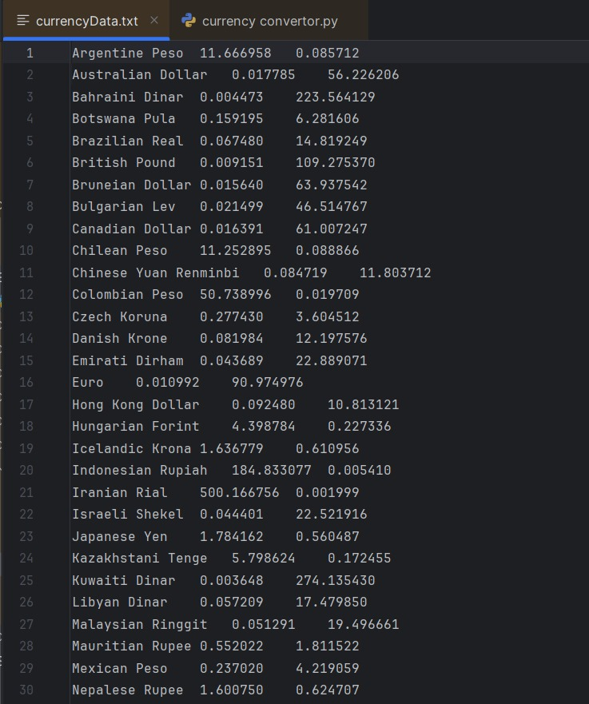

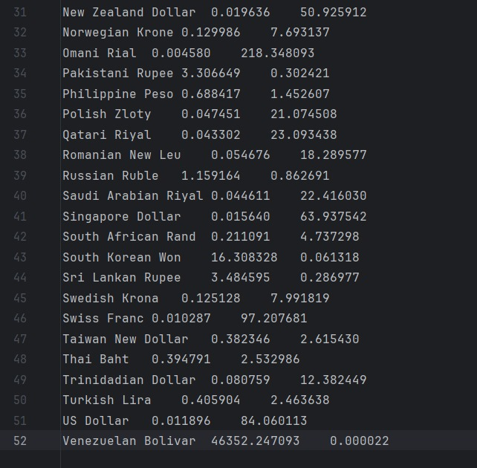

**CODE FOR CURRENCY CONVERTOR**

**IN PYTHON**

**CODE:-**

with open ('currencyData.txt') as f:

lines=f.readlines()

currencyDict={}

for line in lines:

parsed = line.split("\t")

currencyDict[parsed[0]] = parsed[1]

amount=int(input("ENTER AMOUNT \n"))

print("ENTER THE NAME OF CURRENCY YOU WANT TO "

"CONVERT THIS AMOUNT TO? \t",currencyDict.keys())

[print(item) for item in currencyDict.keys()]

currency = input("ENTER ONE OF THE VALUES \n")

print(f"{amount} INR IS EQUAL TO {amount*float(currencyDict[currency])} {currency}")

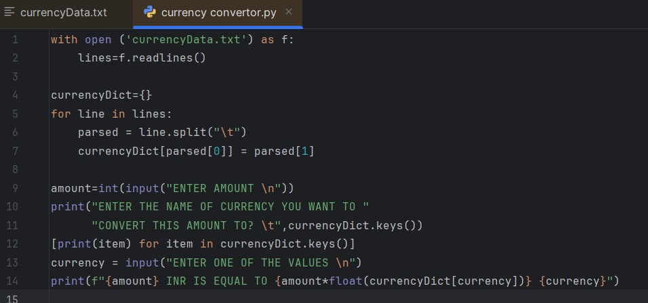

**OUTPUT:-**

**ENTER AMOUNT**

*100*

**ENTER THE NAME OF CURRENCY YOU WANT TO CONVERT THIS AMOUNT TO?**  dict_keys(['Argentine Peso', 'Australian Dollar', 'Bahraini Dinar', 'Botswana Pula', 'Brazilian Real', 'British Pound', 'Bruneian Dollar', 'Bulgarian Lev', 'Canadian Dollar', 'Chilean Peso', 'Chinese Yuan Renminbi', 'Colombian Peso', 'Czech Koruna', 'Danish Krone', 'Emirati Dirham', 'Euro', 'Hong Kong Dollar', 'Hungarian Forint', 'Icelandic Krona', 'Indonesian Rupiah', 'Iranian Rial', 'Israeli Shekel', 'Japanese Yen', 'Kazakhstani Tenge', 'Kuwaiti Dinar', 'Libyan Dinar', 'Malaysian Ringgit', 'Mauritian Rupee', 'Mexican Peso', 'Nepalese Rupee', 'New Zealand Dollar', 'Norwegian Krone', 'Omani Rial', 'Pakistani Rupee', 'Philippine Peso', 'Polish Zloty', 'Qatari Riyal', 'Romanian New Leu', 'Russian Ruble', 'Saudi Arabian Riyal', 'Singapore Dollar', 'South African Rand', 'South Korean Won', 'Sri Lankan Rupee', 'Swedish Krona', 'Swiss Franc', 'Taiwan New Dollar', 'Thai Baht', 'Trinidadian Dollar', 'Turkish Lira', 'US Dollar', 'Venezuelan Bolivar'])

Argentine Peso

Australian Dollar

Bahraini Dinar

Botswana Pula

Brazilian Real

British Pound

Bruneian Dollar

Bulgarian Lev

Canadian Dollar

Chilean Peso

Chinese Yuan Renminbi

Colombian Peso

Czech Koruna

Danish Krone

Emirati Dirham

Euro

Hong Kong Dollar

Hungarian Forint

Icelandic Krona

Indonesian Rupiah

Iranian Rial

Israeli Shekel

Japanese Yen

Kazakhstani Tenge

Kuwaiti Dinar

Libyan Dinar

Malaysian Ringgit

Mauritian Rupee

Mexican Peso

Nepalese Rupee

New Zealand Dollar

Norwegian Krone

Omani Rial

Pakistani Rupee

Philippine Peso

Polish Zloty

Qatari Riyal

Romanian New Leu

Russian Ruble

Saudi Arabian Riyal

Singapore Dollar

South African Rand

South Korean Won

Sri Lankan Rupee

Swedish Krona

Swiss Franc

Taiwan New Dollar

Thai Baht

Trinidadian Dollar

Turkish Lira

US Dollar

Venezuelan Bolivar

**ENTER ONE OF THE VALUES**

*Pakistani Rupee*

100 INR IS EQUAL TO 330.6649 Pakistani Rupee

